
Lesson 10: Play It Again
Unreal Engine (optional advanced track)
VIDEO GAME CREATION
This week: when the round ends, the game actually stops - and pressing R brings it back to a genuinely fresh start.
Open your own [YourName]Game project from Lesson 9 - don't start a new one.
Tip: no new assets this week - this is a logic lesson, and it reuses your very first setup code from Lesson 5.

Setup
- Open your [YourName]Game project from Lesson 9.
- In WBP_HUD's Designer view, add a third Text Block named StatusText, positioned centrally, initially empty.
- Open BP_GameManager and add a new Boolean variable GameActive, default value true - it joins Score, Lives, and EnemiesRemaining as shared game state.
- In the Content Browser, click Add (+) > Input > Input Action, name it IA_Restart. Leave its Value Type as the default (Digital bool), same as your other Input Actions.
- Open IMC_Default (the Input Mapping Context from Lesson 2) and click + Add Mapping. Choose IA_Restart, then set its Key to R. Since IMC_Default is already applied to the player, this new mapping is live immediately.

Level 1 - Minimal (MVP)
When the round ends (win or lose), the game freezes - score and lives stop changing, and further enemy hits/escapes do nothing. Pressing R resets everything and starts a new round.
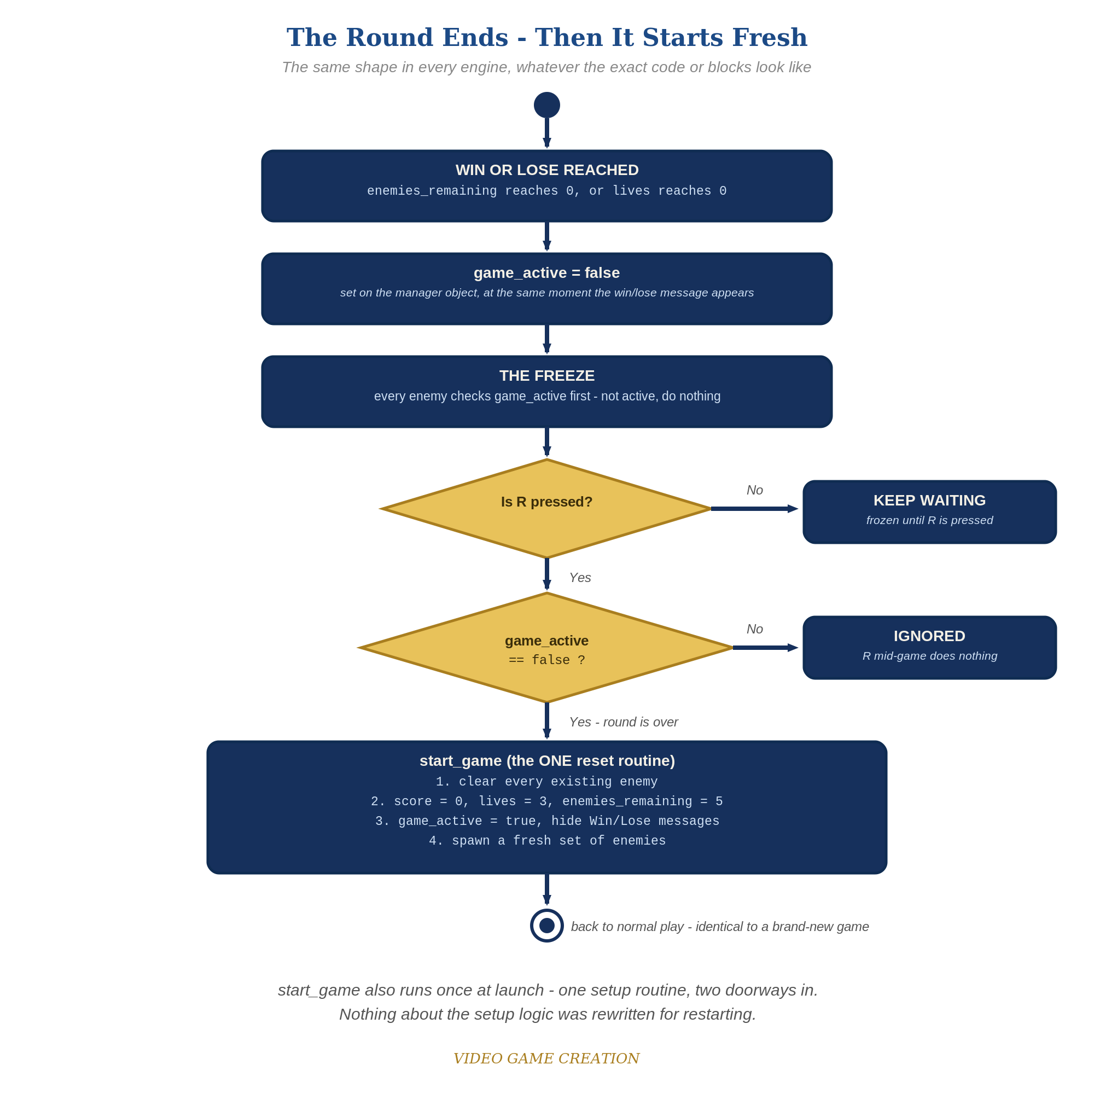
When the round ends, everything freezes - and R, pressed only while the round is over, runs the one reset routine. The same shape in every engine.
- In WBP_HUD's Event Graph, add a Custom Event SetStatus(StatusText: String) that sets the StatusText Text Block's text from the input (code below).
- In BP_Enemy's Event Graph, add a Branch at the very start of Event Tick that reads GameActive from BP_GameManager (use Get Actor of Class(BP_GameManager), then Get GameActive). Wrap all existing movement logic inside the True case, so nothing moves once the round ends.
- In BP_GameManager, build a new Custom Event ResetGame: destroy all existing BP_Enemy actors, reset Score/Lives/EnemiesRemaining/GameActive, call SetStatus with an empty string, call UpdateHUD, then spawn a fresh set of enemies with the same For Loop your spawn logic already used (code below). BP_GameManager owns the shared game state, so the reset lives here and not in the Level Blueprint.
- Change BP_GameManager's Event BeginPlay to create the widget, add it to viewport, set HUDWidget, then call ResetGame instead of spawning enemies directly.
- In HandleEnemyDestroyed's win Branch and HandleEnemyEscaped's lose Branch, when the round ends, also set GameActive = false and call SetStatus with the matching restart-hint message.
- In BP_GameManager's Event Graph, right-click and search for IA_Restart to add an Enhanced Input Action Event node: on its Started pin, Branch on !GameActive -> True: Call ResetGame. (If BP_GameManager does not receive input in your project, enable Auto Receive Input on it in Class Defaults, or add the node to your player Blueprint and call ResetGame on BP_GameManager from there.)
- Click Compile, then Play, play to a win or loss, confirm movement freezes, then press R and confirm everything resets and play resumes.
Highlighted lines are new this week; everything else is code you already have.
WBP_HUD's Event Graph (new):
Custom Event SetStatus(StatusText: String) ->
Set Text(StatusTextBlock, StatusText)
BP_Enemy's Event Graph (revised):
Event Tick ->
Branch(Get GameActive from Get Actor of Class(BP_GameManager)) -> True:
Add Actor World Offset(Delta = (0, -EnemySpeed * Delta Seconds, 0))
Branch(GetActorLocation().Y < -400) -> True: Call HandleEnemyEscaped on BP_GameManager -> Destroy Actor(Self)
BP_GameManager (variables: Score, Lives, EnemiesRemaining, HUDWidget, GameActive):
Custom Event ResetGame ->
For Each (Get All Actors of Class(BP_Enemy)) -> Destroy Actor
Score = 0
Lives = 3
EnemiesRemaining = 5
GameActive = true
Call SetStatus(HUDWidget, "")
Call UpdateHUD(HUDWidget, Score, Lives)
For Loop (First Index 0, Last Index 4) -> Spawn Actor from Class(BP_Enemy) at (BaseX + Index * 150, BaseY, 0) -> Bind Event to OnEnemyDestroyed / OnEnemyEscaped
Event BeginPlay ->
Create Widget(WBP_HUD) -> Add to Viewport -> Set HUDWidget
Call ResetGame
Custom Event HandleEnemyDestroyed ->
EnemiesRemaining = EnemiesRemaining - 1
Score = Score + 10
Call UpdateHUD(HUDWidget, Score, Lives)
Branch(EnemiesRemaining <= 0) -> True:
GameActive = false
Call SetStatus(HUDWidget, "You Win! Press R to Restart")
Custom Event HandleEnemyEscaped ->
Lives = Lives - 1
Call UpdateHUD(HUDWidget, Score, Lives)
Branch(Lives <= 0) -> True:
GameActive = false
Call SetStatus(HUDWidget, "Game Over - Press R to Restart")
Enhanced Input Action Event (IA_Restart), Started ->
Branch(!GameActive) -> True: Call ResetGame
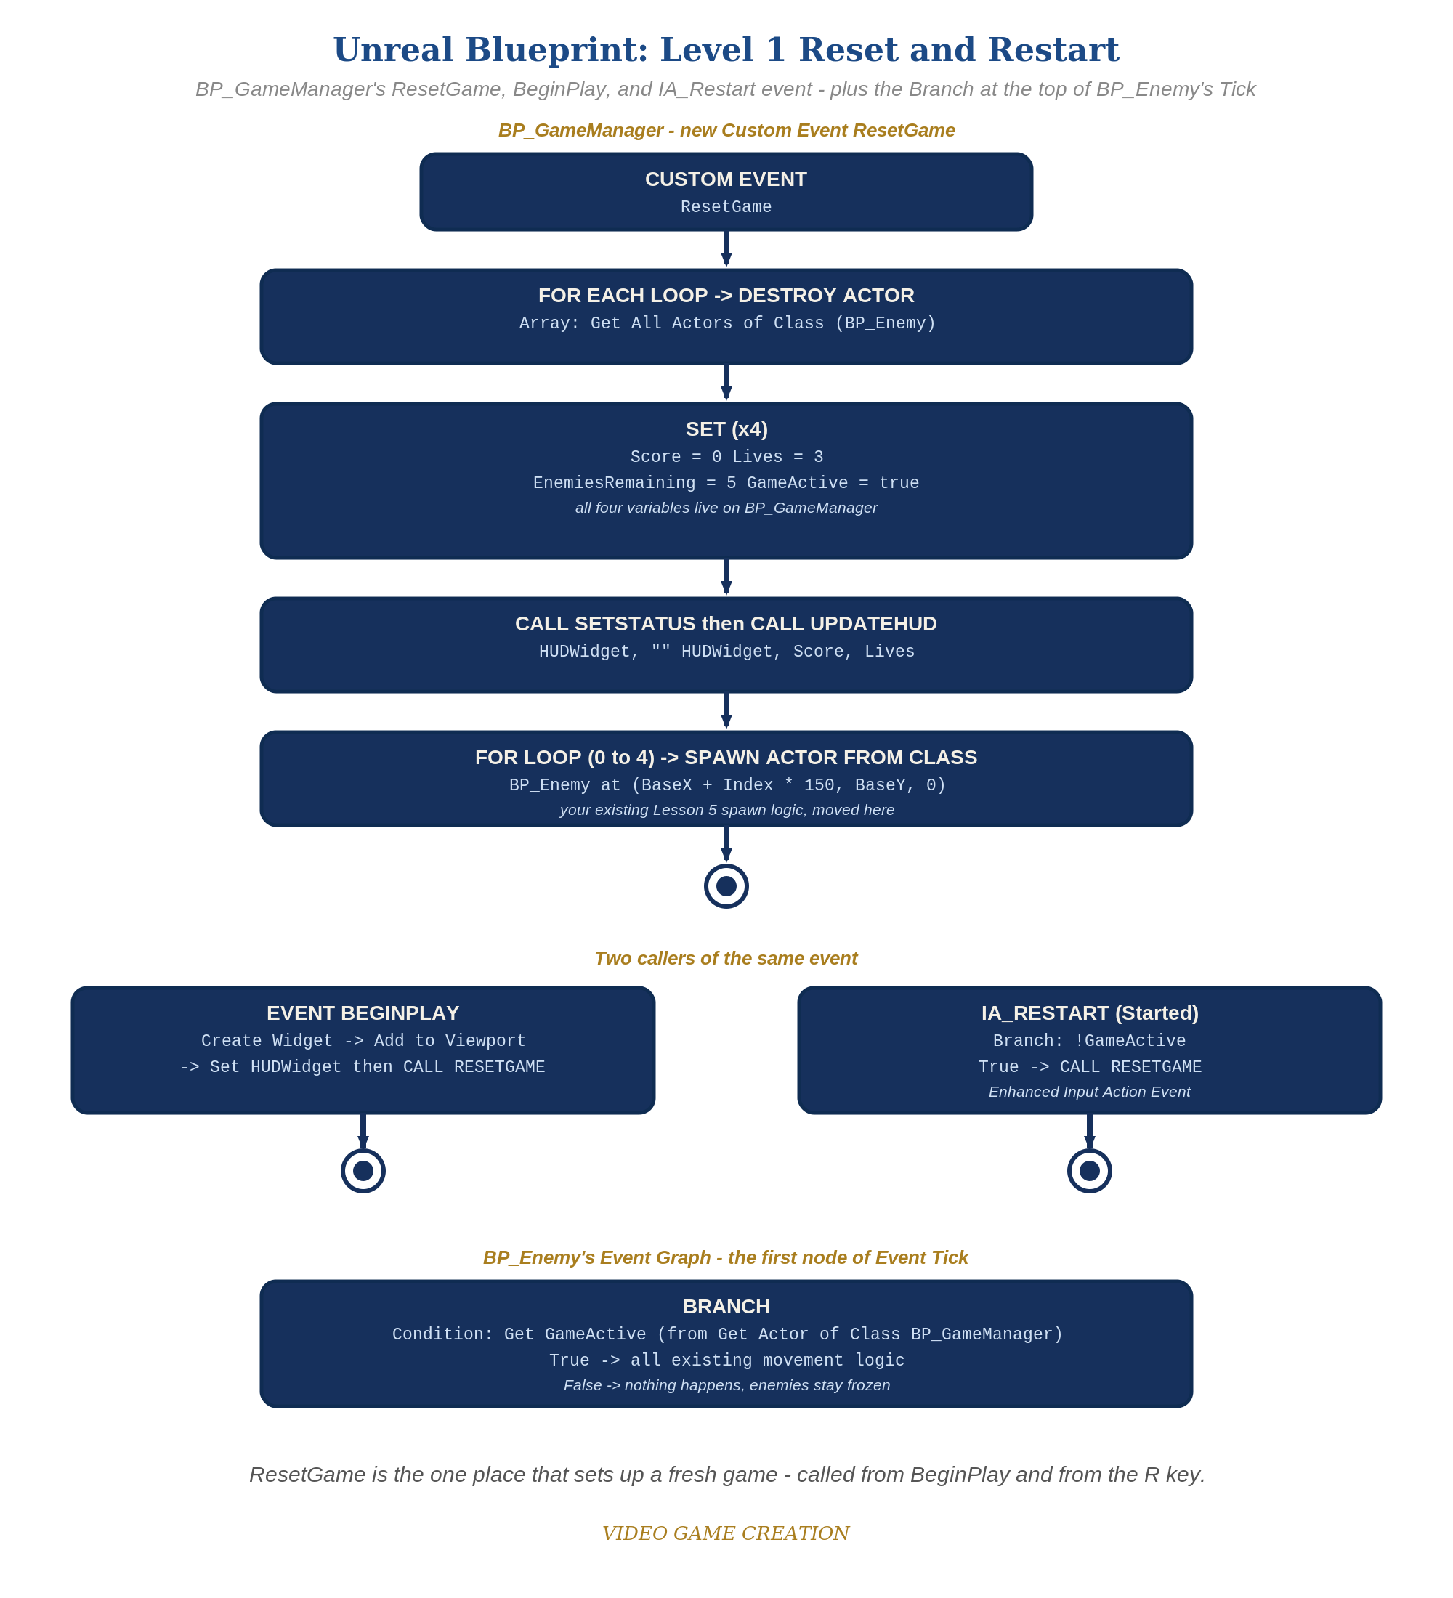
BP_GameManager's ResetGame, BeginPlay and IA_Restart event, plus the Branch at the top of BP_Enemy's Tick - the node-for-node equivalent of the Level 1 code.

Alternate Path: C++ (code, optional advanced track)
The same reusable-reset pattern works in C++ instead of Blueprint nodes.
- Add a ResetGame() function to your game manager class that iterates TActorIterator<ACppEnemy> to destroy existing enemies, resets Score/Lives/EnemiesRemaining/bGameActive, and calls your existing spawn function.
- In ACppEnemy::Tick(), add an early return (if (!bGameActive) return;) at the very top, mirroring the Blueprint path's Branch gate.
This mirrors the Blueprint path's ResetGame Custom Event and Tick Branch exactly - same shape, just from code.

Level 2 - Complete (Alpha/Beta)
A restart is a genuinely clean slate - no leftover enemies, no stale score/lives, and it works correctly no matter how many times in a row you play.
- Play to a win, confirm movement freezes, then press R and confirm Score/Lives/EnemiesRemaining are exactly back to 0/3/5 with no leftover BP_Enemy actors.
- Repeat for a loss - same clean reset.
- Press R while the game is still active and confirm NOTHING happens.

Level 3 - Refined (Ready to Publish) - pick any that interest you
- Visual: animate StatusText's opacity in WBP_HUD instead of it appearing instantly.
- Structure: notice ResetGame is now the single place that sets up a fresh game - called once from BeginPlay and again from the IA_Restart Enhanced Input Action Event. No spawn logic is duplicated, and all shared state still lives on BP_GameManager.

If Something's Wrong
- Restart does nothing when you press R: confirm IA_Restart actually has an R mapping inside IMC_Default, that the Enhanced Input Action Event node is wired directly in the Event Graph (not nested inside another event), that BP_GameManager is set to receive input, and that GameActive is actually false at that point.
- Restart leaves old enemies on screen: confirm "Get All Actors of Class(BP_Enemy)" -> Destroy Actor runs BEFORE the spawn For Loop inside ResetGame, not after.
- Enemies still move after game-over: confirm the Branch(GameActive) wraps ALL of Event Tick's movement logic, not just part of it.
- Get GameActive returns nothing: confirm exactly one BP_GameManager is placed in the level.

Want More?
dev.epicgames.com/community/learning, Student Resource List > Unreal

